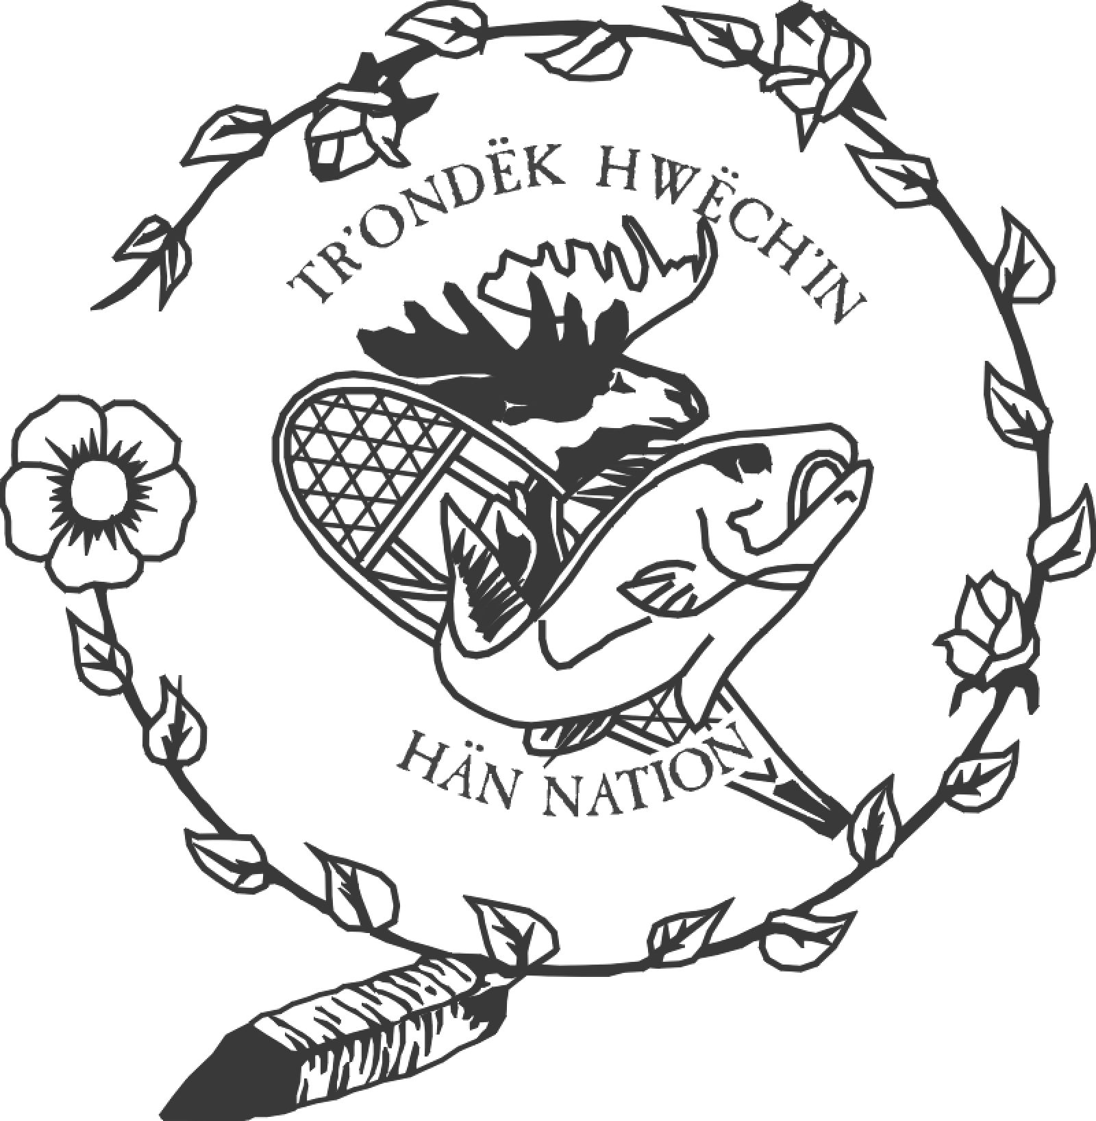
Tr’ondëk Hwëch’in Government Heritage Department
Box 599 Dawson City, Yukon Y0B 1G0
Ph: (867) 993-7100 Fax: (867) 993-6553

Protocol for Conducting Research Related to Tr’ondëk Hwëch’in and/or Accessing Community Knowledge

___ Request to Conduct Research; and/or
___ Request to Access Community Knowledge

Project Information
- Project Manager(s) Name, Title:
- Organization:
- Project Title:
- Project Goals/Purpose:

- Summary of Project Description (attach full description):

- Are there any rules, by-laws, or other limitations that may affect the use of the Community Knowledge in this project? (ie. institutional research guidelines, funding agreements) If yes, please explain:

Conducting Community Research
1. Research Plan attached: _____
2. Why is Community Knowledge necessary for project?

3. Do Tr’ondëk Hwëch’in Citizens need to be involved directly in the project? If yes, explain the nature and scope of their involvement (ie group consultation, individual interviews, etc).

4. What primary topics and/or issues will you cover in this project?

5. What other sources of information have you sought in association with this project?

Access To and Use of Community Knowledge
- Who will use/have access to Community Knowledge?
Primary user(s):
Other user(s):
- Describe your final product. What is the medium, audience, and method of distribution/communication?

- How will the confidentiality of sensitive information be maintained?

- How will Tr’ondëk Hwëch’in Government and Citizens benefit from the project?

- What benefits will others gain from the project, including the associated organization or affiliates and/or project manager?

Ownership and Conditions for Use

Copyright and other intellectual property rights for Tr’ondëk Hwëch’in Community Knowledge material is owned by Tr’ondëk Hwëch’in, all rights reserved. No part of the Community Knowledge material may be reproduced, stored in any material form (including photocopying or storing in any medium or retrieval system by any means including electronic form), or transmitted in any form or by any means, electronic, mechanical, photocopying, recording or otherwise, without the prior written permission of Tr’ondëk Hwëch’in. No commercial use of Tr’ondëk Hwëch’in Community Knowledge material is permitted without the prior written permission of Tr’ondëk Hwëch’in.

All individuals and/or organizations requesting documented Tr’ondëk Hwëch’in Community Knowledge and/or Archives and Collection materials are required to complete and sign a Protocol for Conducting Research Related to Tr’ondëk Hwëch’in and/or Accessing Documented Community Knowledge form.

Tr’ondëk Hwëch’in Heritage Department will be the primary contact for Tr’ondëk Hwëch’in Citizens if interviews are desired. Prior Informed Consent Statement forms must be filled out before any Tr’ondëk Hwëch’in Citizen is interviewed.

Approved reproductions of any of Tr’ondëk Hwëch’in Community Knowledge, Archives, and Collections materials for the above mentioned project is for one-time use only.

The project manager shall furnish Tr’ondëk Hwëch’in, without charge, a minimum of two copies of the final publication and/or product in which the Community Knowledge appears or supports the research. A Protocol for Conducting Research Related to Tr’ondëk Hwëch’in and/or Accessing Documented Community Knowledge form shall be completed before issuing reproductions for commercial use. Royalty fees may apply and will be determined on a case by case basis.

Tr’ondëk Hwëch’in reserves the right to deny any request should the intended use be contrary to the values of Tr’ondëk Hwëch’in.

Tr’ondëk Hwëch’in will respect all rights inherent within its Community Knowledge, Archives and Collections policies including copyright, exhibition rights, intellectual rights, and/or moral rights.

Tr’ondëk Hwëch’in will take no responsibility for the use of its Community Knowledge, Archives and Collections materials, by a third party, in a libelous or illegal manner.

I understand that the Tr’ondëk Hwëch’in Heritage Department will be the holder, in trust for Tr’ondëk Hwëch’in Citizens, of Community Knowledge. Citizens will retain intellectual and moral rights to the material and will receive credit as author and creator whenever the material is published.

I , verify that the above information is true to the best of my ability.

I , have read and agree to the ownership protocol and conditions for use outlined in this form.

Signature Date

Name Affiliation

Tr’ondëk Hwëch’in Heritage Department Date

Contact Information

Tr’ondëk Hwëch’in
Holder, in trust for Tr’ondëk Hwëch’in Citizens, of Community Knowledge:

Tr’ondëk Hwëch’in Government
Heritage Department
Box 599 Dawson City, Yukon Y0B 1G0

Ph: (867) 993 – 7100 Fax: (867) 993 – 6553
Email: jody.beaumont@trondek.ca

Project Manager

Address:

Phone:
Email:

The Tr’ondek Hwëch’in Heritage Department is collecting the personal information on this form for the sole purpose of determining access to the collection. Any information collected on this form will be used for the aforementioned purposes only. The collection of personal information on this form is authorized by section 21 of the TH Freedom of Information and Protection of Privacy Act (FIPPA). Information collected on this form will be retained by the Traditional Knowledge Specialist. Questions about the information on this form can be addressed to the Traditional Knowledge Specialist.
Int.# | Date | Project | Location | Interviewer | Medium | Access/Conditions | Notes | Release
Record of Interviews and/or Research Materials Used (Transcripts, etc)

